Program Amendment Checklist

Course
☐ Any proposed credit changes are updated in the program
☐ Course frequencies match up with program offerings (may affect other programs/departments)
- i.e. on the course outline, if “When do you plan to offer this course” says “Spring” and the course is placed in Fall term on the amendment, the outline needs to be updated to include Fall, or the course needs to be moved to a spring term in the program.
☐ Prerequisites/Corequisites in correct terms
☐ Elective credit range listed in program matches actual credits of available elective courses
☐ Elective courses are offered in terms that match up with where the electives are listed in the program
☐ Courses that are listed in programs multiple times need to be marked as “Yes” for the “Can this course be repeated for credit in a degree” question on the course outline.

Program Credits
☐ Credits per term
- <6 credits per term, student not eligible for financial aid
- 12<x<18, full time student
- >18 credits per term, student needs permission (ARC 300)
- Credits per term are balanced
☐ Total credits within acceptable range for approved program type
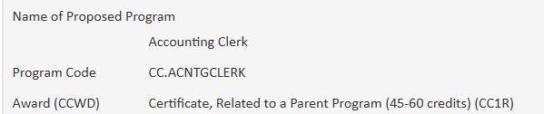
- Credit range is listed at the top of each program in CourseLeaf

Overall Program
☐ Related Instruction (ISP 181)
- One-Year Certificates (45+ credits): at least 3 credits of Computation, Communication, and Human Relations
- AAS and AGS: at least 3 credit of Computation, Communication, and Human Relations, and at least 1 credit of PE/Health/Safety/First-Aid
☐ Credit changes exceeding 30% must be suspended and recreated as new with CCWD. Curriculum Office will calculate credit change using CCWD criteria
- Approved program credit x .30 = Maximum Allowed Credit Change
- Round down to nearest whole number

Parent Program/Associated Programs
☐ Double-check CCWD for associated/parent programs
- Listed on program amendment form

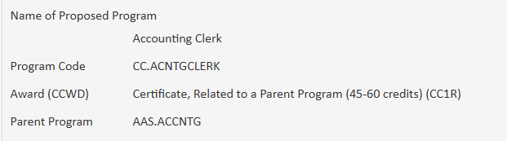
☐ Associated Programs/Career Pathway Certificates must be wholly contained within the parent program (OAR 589-006-0050 (9))
☐ Career Pathway Certificates’ parent programs must be an AAS or a 45 credit or more Certificate (OAR 589-006-0050 (15)
☐ AAS Option must contain at least 70% of the base AAS curriculum credits
- Approved parent AAS credit x .70 = Minimum Amount of Credit Overlap Required
- Round up to nearest whole number

Other considerations
☐ Should the program description, outcomes, or careers be changed due to the curriculum changes?
☐ Do other departments need to be consulted about when courses are offered or which course is appropriate for the program?
☐ Will this affect the website or catalog?
☐ What is the impact of the change?

